What not to do when creating an infographic
Taken from https://www.smashingmagazine.com/2011/10/the-dos-and-donts-of-infographic-design/
- Don’t tell the reader with an explanation. Show the information visually whenever possible.
- Don’t be satisfied with just a traditional bar graph or pie chart. Find ways to dress up the traditional format:
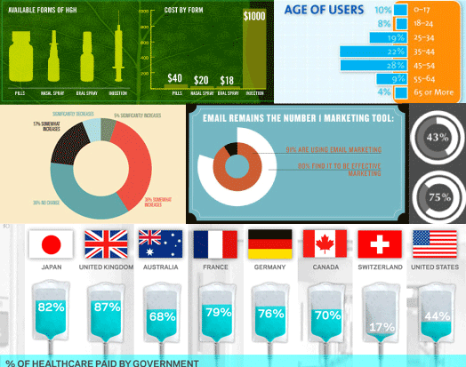
- Don’t just use large font size for a large number. Any time a research number is provided to you for an infographic, ask yourself how it can be visualized.
- Don’t make the title so big or fancy that it becomes distracting and takes away from the reason we are looking at the infographic in the first place.
- Don’t use dominant dark colors and neons that typically do not translate well on infographics on websites; neon on black can be hard to read, and if there is a lot of data, taking it all in will be a challenge. Also, avoid white as a background whenever possible. Infographics are often shared on multiple websites and blogs, most of which have white backgrounds. If your infographic’s background is also white, then deciphering where it begins and ends will be difficult.
- Don’t use a gazillion different colors. Choose three primary colors. Of the three, one should be the background color (usually the lightest of the three), and the other two should break up the sections. If you need to add other colors, use shades of the three. main colors. This will keep the palette cohesive and calming, rather than jarring.

